Local Minister’s Orientation upon Election

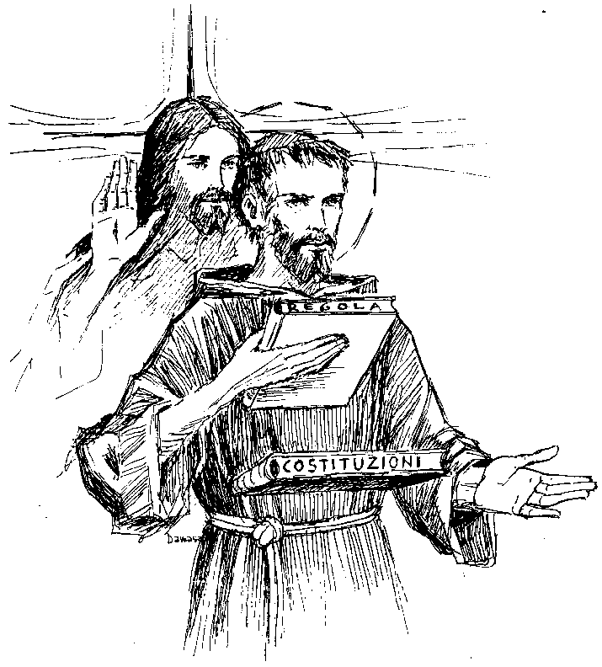
Congratulations! You have been elected (or re-elected)
to serve your Franciscan brothers and sisters in a very special way!

I, the fraternity Minister, accept this responsibility and service of leadership. Before almighty God, I promise to live daily the Gospel life in the spirit of our seraphic father St. Francis and to exercise my new ministry to the best of my ability. I ask the guidance of the Holy Spirit and the cooperation of the fraternity, so that together as the Family of Francis we may witness to the Gospel, may be instruments of peace, and may build a more fraternal and evangelical world, so that the Kingdom of God may be brought about more effectively. Amen.
(adapted from the Ritual of the Secular Franciscan Order, pp. 42 – 43)

The rationale for the Regional Executive Council assisting the local ministers in understanding their duties is set forth in the General Constitutions: article 62.2.e. to provide for the formation of those responsible for animation; and 62.2.f. to offer to local fraternities activities which support their formative and operative needs.

The local minister should have the following texts at hand:

* Essential Documents of the Secular Franciscan Order (2014 revision)

* Ritual of the Secular Franciscan Order

* For Up to Now Foundational Topics for Initial Formation Manual (2011, a.k.a. The F.U.N. Manual) and the associated For Up to Now CD; also Forming the Formators, 5 DVD set (each Fraternity received at the April 26/27, 2014 RFC meeting)

* Handbook for Secular Franciscan Servant Leadership (2010 revision)

* Handbook for Spiritual Assistance to the Secular Franciscan Order (2012 revision)

* Regional Directory (This directory contains the names, addresses, phone numbers and emails of the Regional Executive Council members and members of each local fraternity.)

* Regional Guidelines

[adapted from materials developed by Fr. John Sullivan, O.F.M., Revised by Deacon Dave & Thérèse Ream, O.F.S., January 2017]

SESSION ONE (1st & 2nd months): Read & Review: General Constitutions (GC), articles 30.3, 31 & 32, 49 – 53 & 82; National Statutes (NS), articles 18.7 & 18.8; and The Rule of the Secular Franciscan Order, article 26.
1. Read article 31 (GC). List the qualities of a servant leader. What are the duties of a servant leader?
2. Read article 32 (GC). How does a person serve the fraternity?
3. Read articles 30.3, 50.2.e (GC); articles 18.7 & 18.8 (NS). Explain “fair share” or Franciscan Stewardship. Who is supposed to receive a stipend and when?
4. Read article 50.2 (GC). How does our council attend to each of these eight (8) duties? Which ones need more attention?
5. Read article 51.1 (GC). Describe the difference between the respective roles of the COUNCIL and the MINISTER. How are they related? Does our fraternity follow this plan?
6. Read article 51.2 (GC). What are the differences between a pastoral and a fraternal visitation? How do you go about asking for a pastoral visitation? How often? When was your last one? How do you go about asking for a fraternal visitation? How often? When was your last one?
7. Read articles 49, 52 & 82 (GC). What is the makeup of the local council? What offices are incompatible and at which levels? Do the officers in your fraternity know their respective duties? Do you, as minister, have them report on their duties at your regular monthly council meetings? How does the council work together on formation matters?
8. Read article 53 (GC). How does the fraternity reach out to maintain contact with excused members?

SESSION TWO (3rd & 4th months): Read & Review: the Handbook for Secular Franciscan Servant Leadership.
1. Which topics in the Handbook should our council review? (Plan to cover these topics in the course of the next year.)
2. What are the four essential elements of a fraternity meeting/gathering? Sketch a timeline for your regular fraternity meeting/gathering. How much time is allotted to each of the 4 essential elements? Should changes be made? If yes, what? (see LEADER GUIDE 12)

SESSION THREE (5th & 6th months): Read & Review: (GC) articles 37 – 44;
(NS) articles 16.4 & 19.
1. How does the formation team function?
2. Describe the various phases of formation and the required time spent in each phase: Orientation? Inquiry? Candidacy? Newly-professed? Ongoing?
3. Do we as council consult the fraternity Formation Director and the Spiritual Assistant before accepting a person into candidacy and then prior to profession?
4. Do we as council use the secret ballot for approving a candidate for profession?
5. How much time is devoted to ongoing formation at the monthly meeting/gathering?
6. Do we as council presume too much about what the members are reviewing on their own?
7. How do we help members reflect on their life experiences in light of our Franciscan vocation?
8. In what ways do we as council assist the members in developing their Franciscan spirituality?
9. What is the external sign of the O.F.S. in the United States?

